**Web**

**Login Page**

**Test Case - 1 (Login credential Admin account)**

|  |  |
| --- | --- |
| Objectives | To ensure the User can log in using credentials |
| Actions | The user enters the appropriate user's credentials on the login page and clicks the login button. |
| Expected Result | The user should be logged into the system and redirected to the home page. |
| Actual Result | The user was logged into the system and redirected to the home page. |
| Test | The test was successful. |

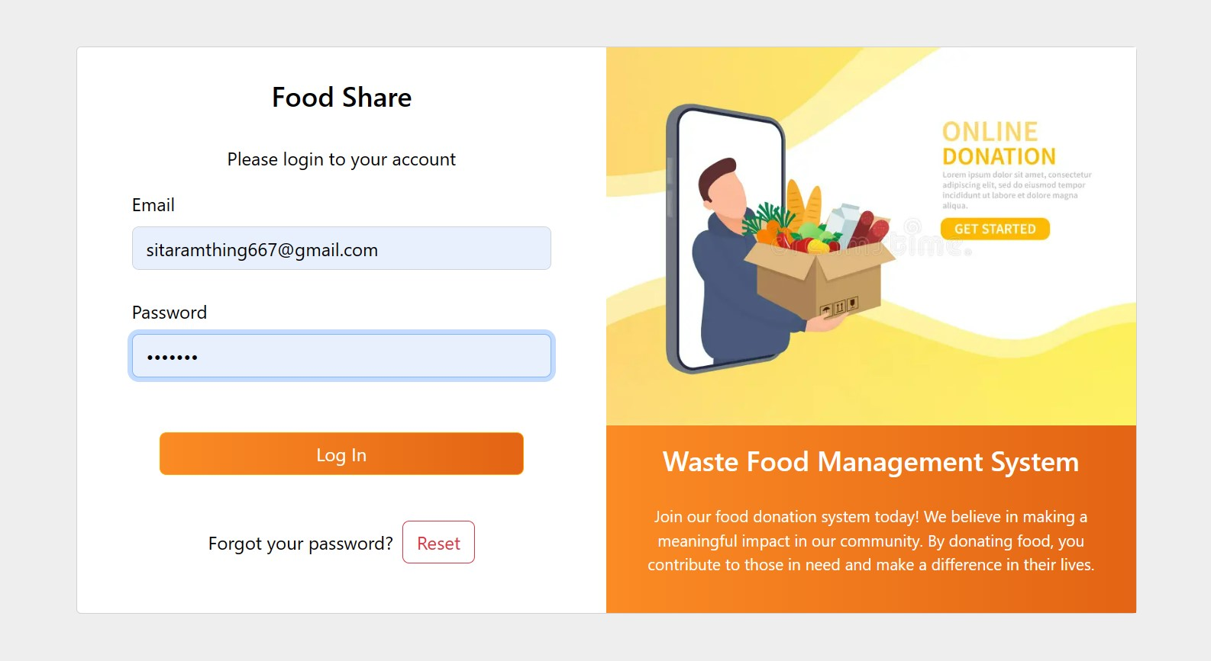

**Test Case – 2 (Active and registered user try to log in to admin panel)**

|  |  |
| --- | --- |
| Objectives | To ensure the User can try registering an account login to the system in the admin panel. |
| Actions | The user enters a resisted account details and clicks the login button. |
| Expected Result | The form will display an error message at the bottom that states, “Invalid Credentials”. |
| Actual Result | The form displays an error message at the bottom that states, “Invalid Credentials”. |
| Test | The test was successful. |

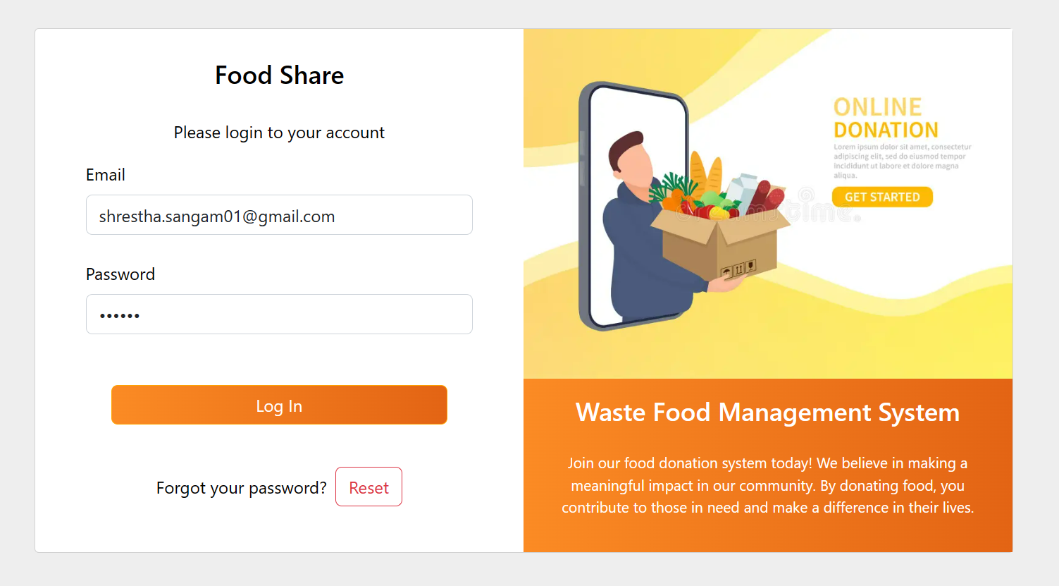

**Reset Password Page**

**Test Case – 7 (Enter email but not password)**

|  |  |
| --- | --- |
| Objectives | To ensure the email is provided and the password is empty then show the password field error message. |
| Actions | The admin fills the email but did not fill in the reset password fill. |
| Expected Result | The form will display an error message at the bottom that states, “Fill out the form”. |
| Actual Result | The form displays an error message at the bottom that states, “fill out the form”. |
| Test | The test was successful. |

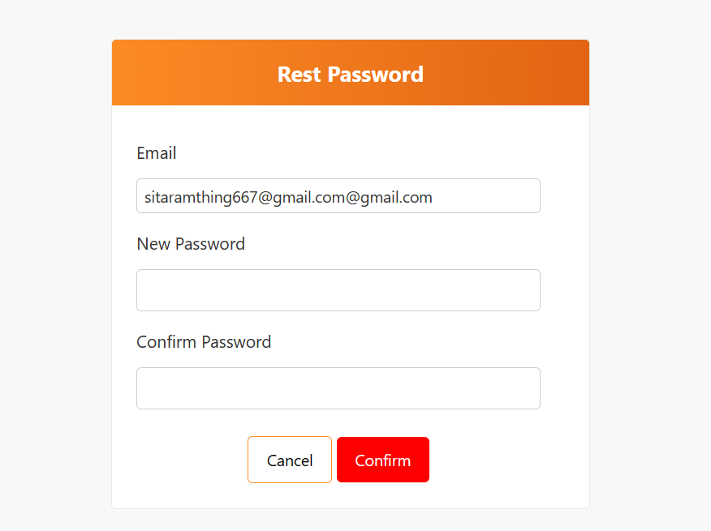

**Test Case – 8 (Password reset success)**

|  |  |
| --- | --- |
| Objectives | To provide email and both password fields and redirect to the login page. |
| Actions | The admin provides the email and password the valid email and same password then clicks the confirm button. |
| Expected Result | The password is successfully reset and navigate to the login screen. |
| Actual Result | The password is successfully reset and without any exception redirected to the login page. |
| Test | The test was successful. |

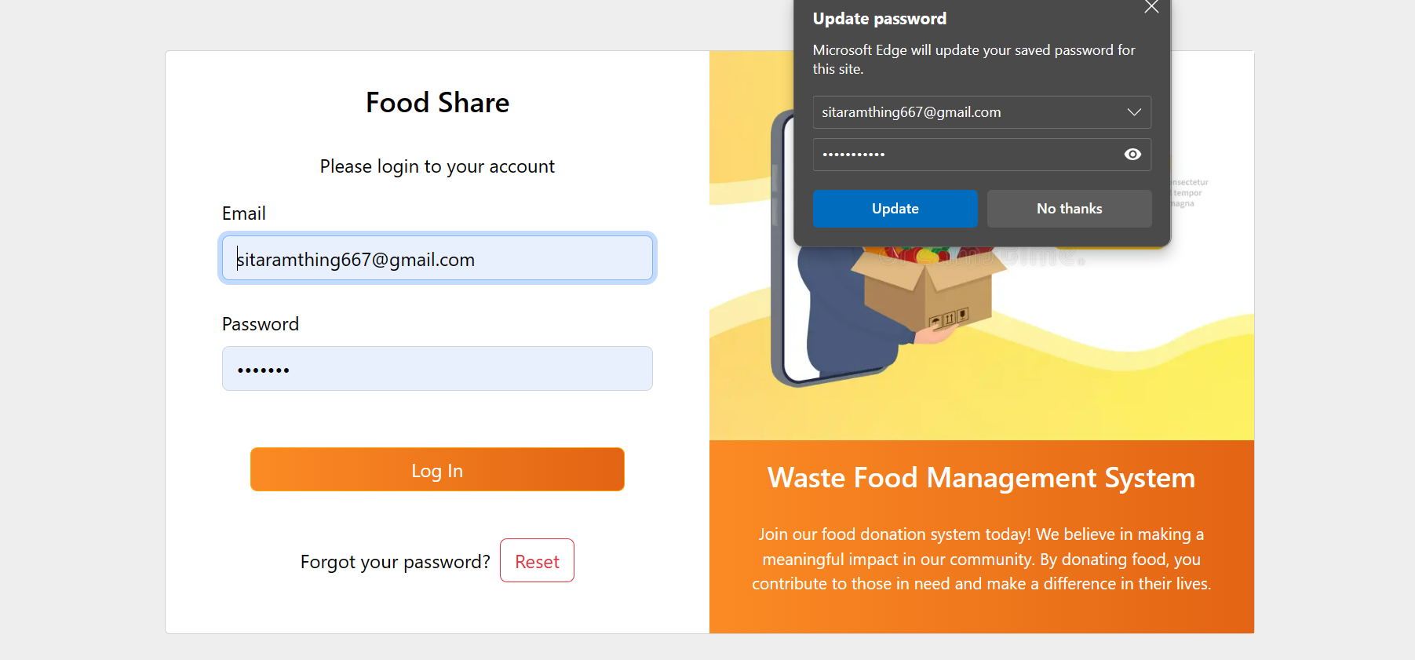

**Mobile**

**Test Case – 9 (Install application show Indro and welcome screen)**

|  |  |
| --- | --- |
| Objectives | To display the welcome screen that asks for Google Maps permission after the user successfully logs in and requests notification permission. |
| Actions | The user installs the application, completes the installation process, and navigates from the intro slider to the welcome screen. Then, the application displays the Google Maps permission request. After logging in, it asks for notification permission, where the user can click to allow the permission.   * Clicks the **WHILE USING THE APP** button for Map. * Clicks the **ALLOW** button for Notification. |
| Expected Result | The application can be successfully accessed for notification and Google Maps permission, and successfully displays the map and receives notifications. |
| Actual Result | The user grants permission to display the Google Map and receives notifications. |
| Test | The test was successful. |

**Test Case – 9 (Register screen validation)**

|  |  |
| --- | --- |
| Objectives | To display the intro slider and welcome screen only during the first installation of the mobile application, and not to show them thereafter. |
| Actions | The user installs the application, completes the installation process, navigates from the intro slider to the welcome screen, closes the app, and then reopens it.   * Clicks the next or skip button. |
| Expected Result | Upon the initial installation and opening of the app, the user navigates from the intro slider to the welcome screen. Subsequent openings of the app should bypass the intro slider and welcome screen, directly opening the login screen. |
| Actual Result | After the initial installation, the application displays the slider and welcome screen. However, upon reopening the app, it does not show these screens and instead redirects to the login screen. |
| Test | The test was successful. |